**Final Project**

**2.E-commerce Return Rate Reduction Analysis**

**Objective:** To Identify why customers, return products and how return rates vary by Category, suppliers.

**Introduction:** In the highly competitive landscape of e-commerce, customer satisfaction and operational efficiency are key drivers of business success. However, one of the persistent challenges faced by online retailers is the high rate of product returns, which can significantly impact profitability, inventory management, and customer loyalty.

This analysis focuses on identifying the underlying causes of product returns, uncovering patterns and trends through data, and recommending actionable strategies to reduce return rates. By leveraging historical order data, return reasons, customer profiles, and product details, the goal is to gain a deeper understanding of what drives returns and how they can be minimized.

Reducing return rates not only leads to cost savings but also improves the customer experience, enhances brand trust, and contributes to sustainable business practices. This project aims to empower decision-makers with insights that are both strategic and practical, leading to long-term business growth.

**Toos Used:**

* Python
* Power BI
* SQL

**Steps Involved in Building Project:**

This interactive Power BI dashboard provides deep insights into return rates vary bycategory, Return Rate, Return probability by category. Let's break it down:

Key Metrics:

* Total Orders: 3660
* Returned Orders: 545
* Return Rate: 0.15%

Detailed Insights:

* Total Orders by Payment Method (most Payment is by both Credit card and UPI 21% each)
* Average of Return Probability by Category (Home and Kitchen is the most avg-return-probability-0.54)
* Return and Return Probability trend (Most Return and Return Probability is in the month of October)
* Monthly Orders by Category (Books Category is the most ordered)

Filters Available:

* Payment Method
* Category

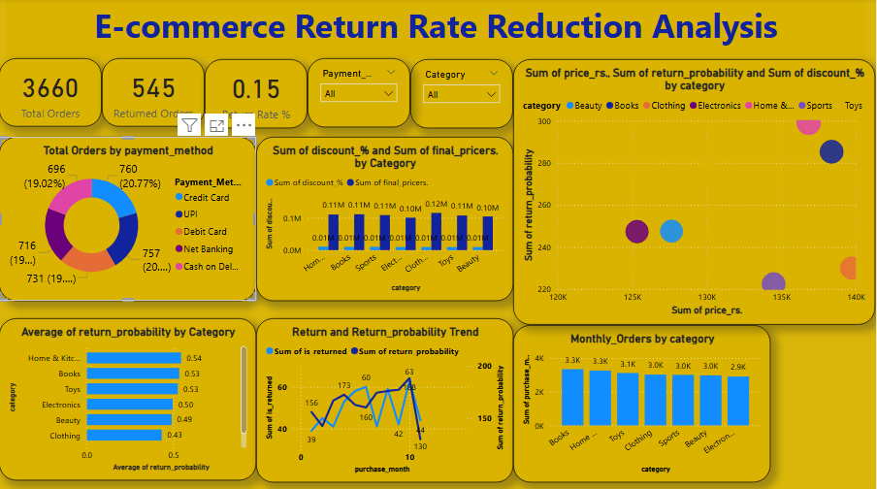

**Conclusion:** The E-commerce Return Rate Reduction Analysis provides valuable insights into the patterns and causes of product returns, revealing critical areas for improvement in product quality, logistics, and customer communication. By leveraging data from various sources—such as order history, return reasons, and customer behaviour—the analysis helps businesses identify high-risk products, customer segments, and operational inefficiencies.

Implementing the recommended data-driven strategies, such as optimizing product descriptions, improving size guides, enhancing quality control, and using predictive models, can significantly reduce return rates. This not only improves profitability and operational efficiency but also strengthens customer trust and satisfaction.

Ultimately, a well-designed return reduction strategy, supported by continuous data monitoring through dashboards, enables e-commerce businesses to create a more seamless, cost-effective, and customer-friendly shopping experience.